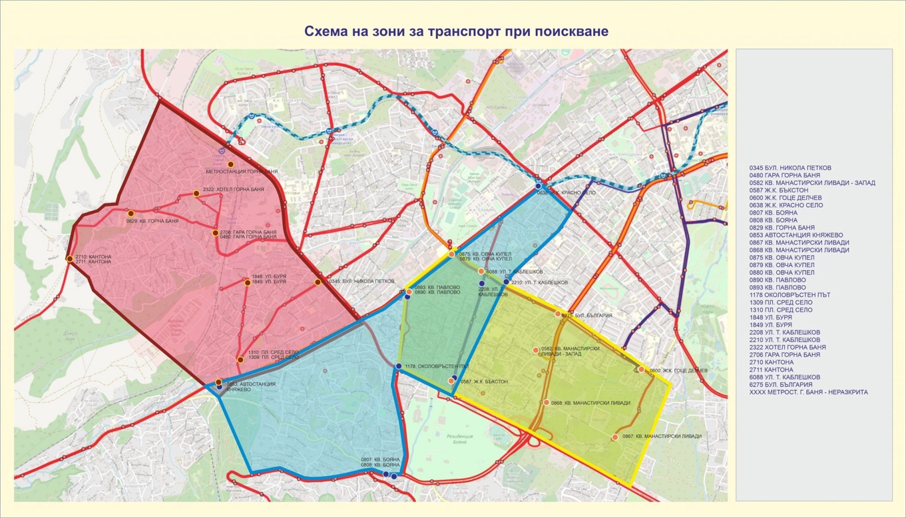
Figure 2 Map of the Neighbourhood Zones the Project was Implemented In

